**Comprehensive Report**

**Introduction:**

This work describes how to set up a virtual router running Ubuntu to facilitate communication between PCA and PCB. Network Address Translation (NAT), Dynamic Host Control Protocol (DHCP), firewall, and basic routing functionalities will all be configured under the. The network interfaces enp0s3, enp0s8, and enp0s9 are utilized for this. I designed the router and the clients using Ubuntu and Oracle Virtual Machines.

**Tools are Used:**

* **Linux Distribution:**

Ubuntu Server was sourced from the official Ubuntu website.

* **Virtualization Platform:**

Oracle VM VirtualBox was sourced from the official VirtualBox website.

**Installation Steps:**

1. **Oracle VM VirtualBox Installation:**

I downloaded Oracle VM VirtualBox from the official website (<https://www.virtualbox.org>) and followed the installation instructions for my operating system. Once the download was complete, I located the installer file and double-clicked on it to start the installation process. I followed the on-screen instructions to install VirtualBox on my computer. After the installation was complete, I launched VirtualBox to proceed with creating the Ubuntu Server virtual machine.

1. **Ubuntu Server Installation:**

To create a new virtual machine in VirtualBox, I clicked on the "New" button. A new window opened. In the new window, I entered a descriptive name for my Ubuntu Server virtual machine in the "Name" field. I chose "Linux" as the type and "Ubuntu (64-bit)" as the version. I clicked "Next" to continue. I allocated sufficient memory (RAM) to the virtual machine, adjusting the memory size according to my system's resources. I created a new virtual hard disk by selecting "Create a virtual hard disk now" and clicked "Create" to proceed. I chose the file type for the virtual hard disk, selecting the default option, "VDI (VirtualBox Disk Image)." I clicked "Next." I selected "Dynamically allocated" for the storage on the physical hard disk and clicked "Next." I specified the size for the virtual hard disk, using the default size. I clicked "Create" to create the virtual hard disk.In the VirtualBox main window, I selected the newly created virtual machine and clicked on the "Settings" button.In the "Settings" window, I navigated to the "Storage" tab.Under the "Controller: IDE" section, I clicked on the disk icon with a plus sign to add a new optical drive.In the optical drive settings, I chose "Select Disk Image" and browsed to the location where I had saved the Ubuntu Server ISO file obtained from the official Ubuntu website (<https://ubuntu.com/download/server>). I selected the ISO file and clicked "OK."I clicked "OK" to close the "Settings" window.I started the virtual machine by selecting it in the VirtualBox main window and clicking the "Start" button. The Ubuntu Server installation process began. I followed the on-screen prompts and configured the following settings as needed:

* I selected my preferred language.
* I chose my keyboard layout.
* I configured my network settings.
* I selected the virtual hard disk created earlier as the installation destination.
* I followed the prompts to set up a strong root password and create a user account with sudo privileges.
* Once the installation was complete, the virtual machine rebooted.

*Configuration steps:*

1. **Network Configuration:**

I opened VirtualBox and selected the Ubuntu Server virtual machine. I clicked on the "Settings" button to open the settings window for the virtual machine. In the settings window, I navigated to the "Network" tab.To add a network adapter, I clicked on the "Adapter 1" tab.Under the "Attached to" dropdown menu, I selected "NAT" to enable external network and internet access for the virtual machine.I made sure that the "Enable Network Adapter" checkbox was checked.I adjusted the "Adapter Type" and "Promiscuous Mode" settings as necessary to match my network requirements.Next, I clicked on the "Adapter 2" tab to add another network adapter.Under the "Attached to" dropdown menu, I selected "Internal Network" to enable internal network communication between virtual machines.In the "Name" field, I entered the name of the internal network that I wanted to use or created a new one.I made sure that the "Enable Network Adapter" checkbox was checked.I adjusted any other necessary settings for the second network adapter.Finally, I clicked "OK" to save the network settings and closed the "Settings" window.

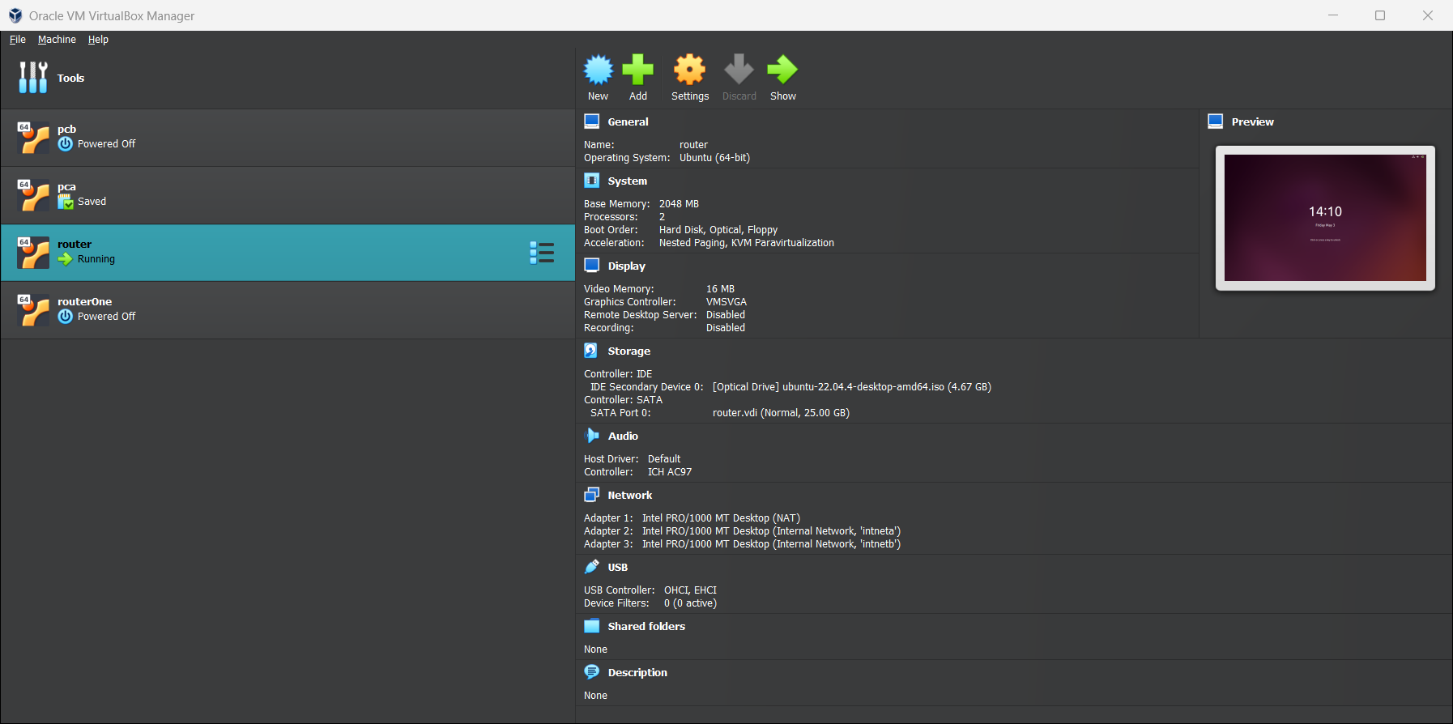

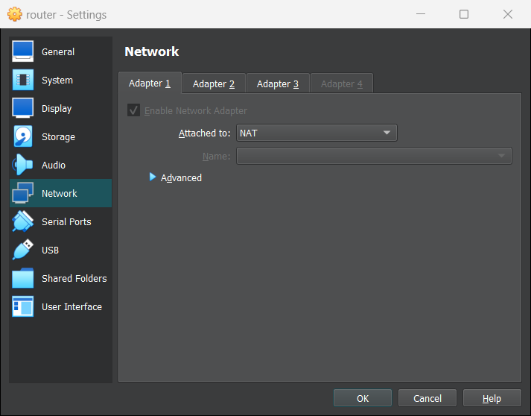

1. **IP Forwarding:**

For the IP forwarding , I opened the terminal for the router to allow IP forwarding . I edited sysctl.conf file using a text editor called nano.



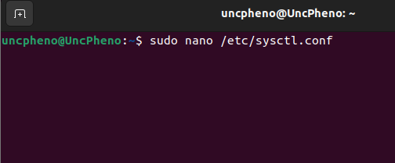

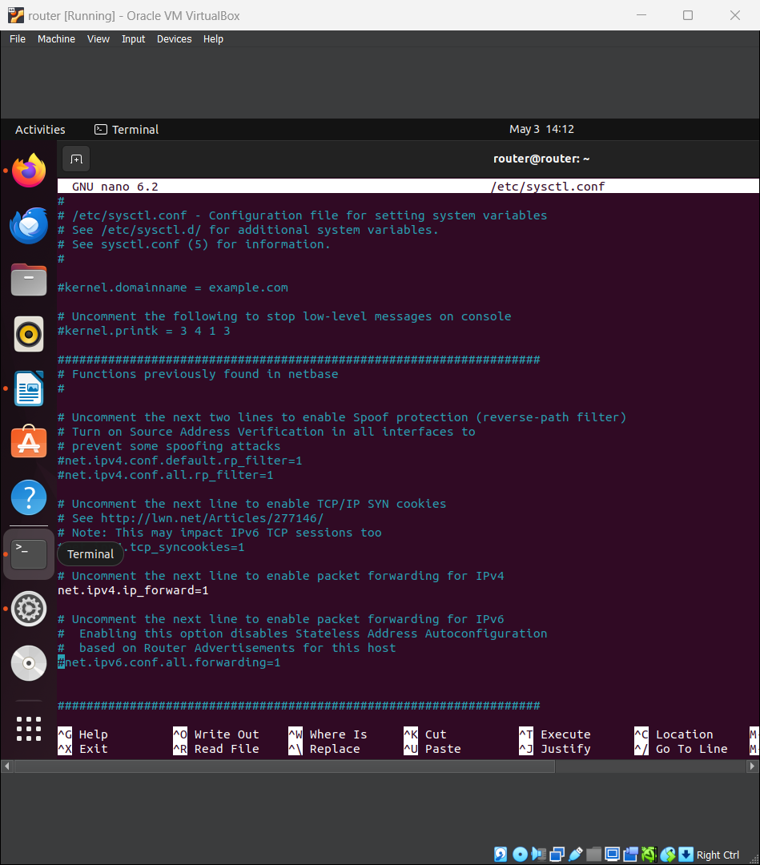

Then I uncommented the line net.ipv4.ip_forward=1 to enable IP forwarding.



I apply the changes by running : sudo sysctl -p

**4.NAT Configuration:**

I opened the terminal for the Ubuntu Server virtual machine. I ran the following command in the terminal to update the package lists:



Once the package lists were updated, I ran the following command to install iptables:

To create a new iptables rule for NAT, run the following command in the terminal: sudo iptables -t nat -A POSTROUTING -o <enp0s3> -j MASQUERADE



To save the iptables rules to persist across reboots I used: sudo iptables-save > /etc/iptables/rules.v4.

1. **DHCP Setup:**

I ran the following command in the terminal to update the package lists:



* Once the package lists were updated, I ran the following command to install the isc-dhcp-server package:sudo apt-get install isc-dhcp-server.



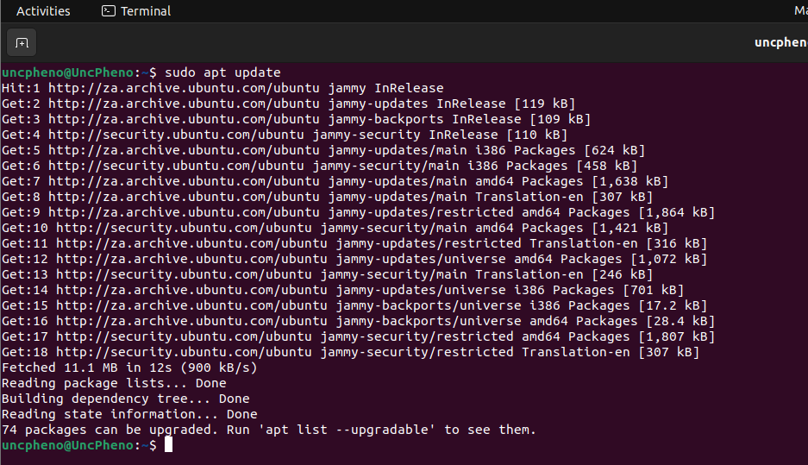

* I ran the following command in the terminal to open the dhcpd.conf file for editing:sudo nano /etc/dhcp/dhcpd.conf.



This command opened the dhcpd.conf file in the nano text editor with administrative privileges.

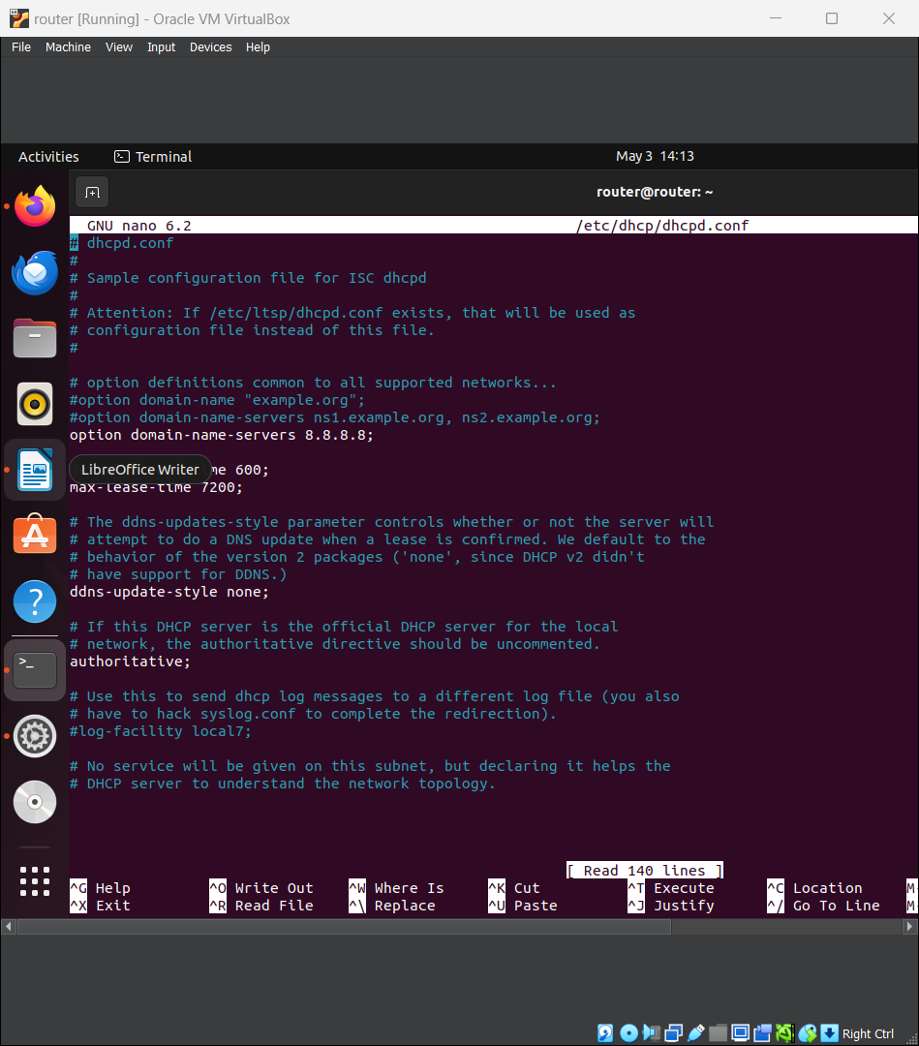

* Defining DHCP settings inside dhcp.conf

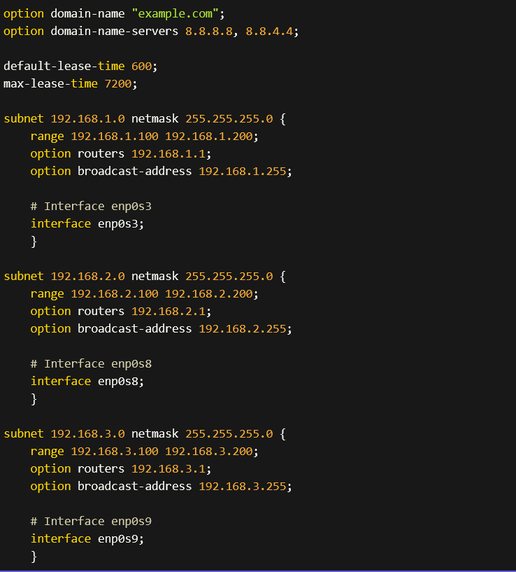

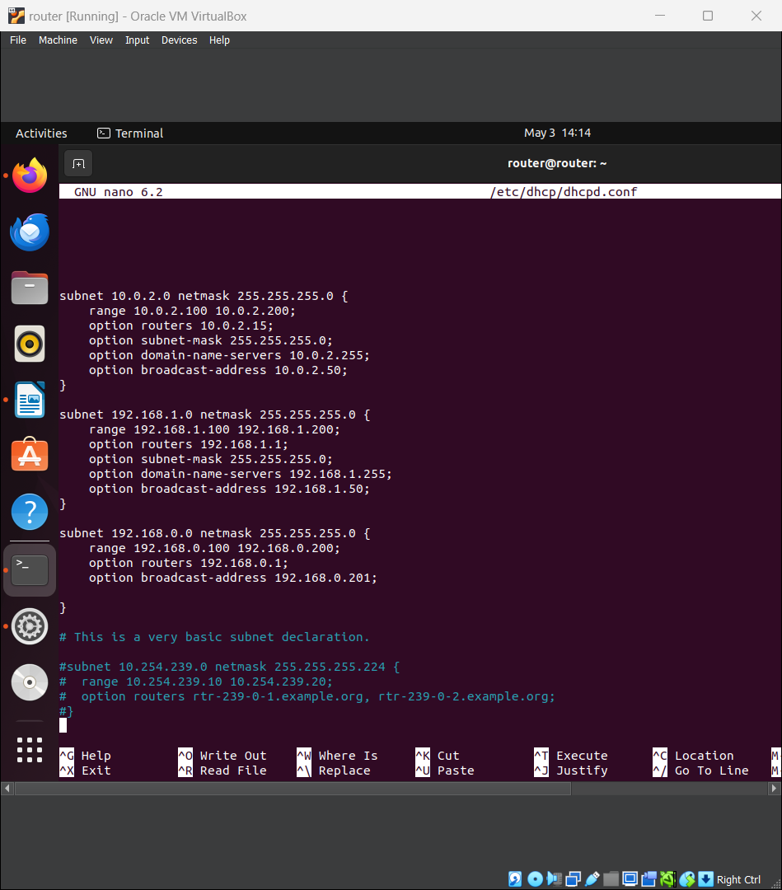

* Starting the DHCP server service : sudo systemctl start isc-dhcp-server.



* Enable the DHCP server to start on boot: sudo systemctl enable isc-dhcp-server.



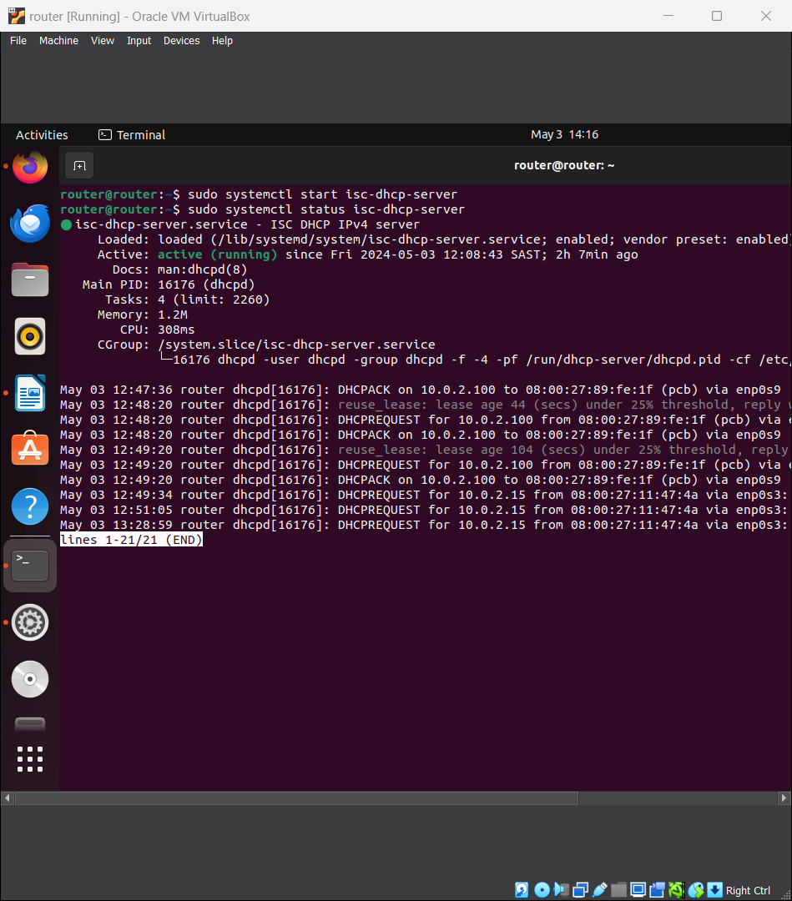

Dhcp is up and running.

1. **Firewall Configuration:**

* Set up firewall rules using iptables to allow or block traffic as per your network security requirements.



* Define rules for inbound and outbound traffic, ensuring necessary services are accessible while unauthorized access is blocked.



Block all other incoming traffic:



**7.Configure SSH**

I used : sudo apt install openssh-server to start install ssh to install SSH



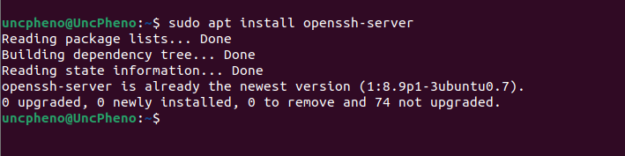

**Now lets start SSH to check if its active or not .**



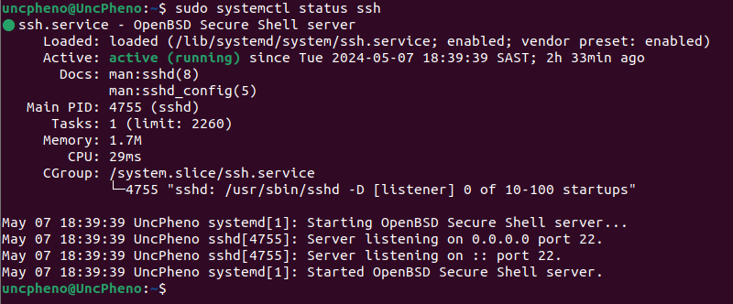

**8. Ping:**

Communication : ping 10.0.2.15

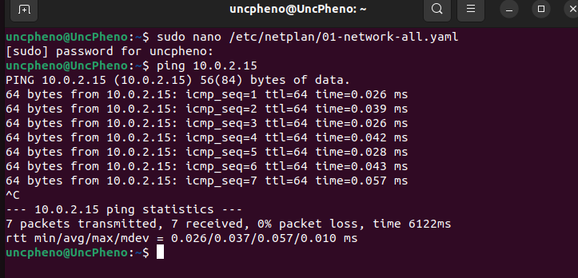

**9. Challenges and Lessons Learned:**

* **Network Interface Configuration:**

Misconfiguration of network settings ,Incorrect IP addresses or network modes can cause connectivity problems.

Compatibility problems ,In order for various network adapters or operating systems to function correctly in a virtualized environment, certain configurations or drivers may be needed. Interoperability with the host network: When numerous virtual machines need to communicate with the external network or with each other, it might be difficult to coordinate network settings between the host computer and the virtual machines.

* **Firewall Configuration:**

Rule conflicts , Inadequate firewall rule configuration can lead to conflicts that either permit unwanted access or obstruct intended network traffic. Specificity and granularity ,It might be difficult to create firewall rules that balance security and usability. While overly permissive rules can expose the system to assaults, unduly rigid rules have the potential to impede genuine network communication. Dynamic environments ,Network topologies and dynamic IP addresses are common features of virtualized settings. These features can make firewall design more difficult and necessitate frequent modifications to account for them.

**Troubleshooting:** Debugging network issues within a virtualized environment required patience and meticulous attention to detail.